**Please remove this from the home page of** [**www.officemoves.com**](http://www.officemoves.com) **(Leave it on the podcast page of** [**https://officemoves.com/podcast/**](https://officemoves.com/podcast/) **but remove the link and story from my home page.)**

### Our next COMMERCIAL RELOCATION HAPPY HOUR PODCAST is Episode 38: “WHAT? A BRAINSTORM THAT HIT AT 3 O’CLOCK IN THE MORNING THAT WILL REVOLUTIONIZE OFFICE MOVING” with Ed Katz, Rob Clark, and a Special Guest. As always, this podcast is hosted by Ed Katz, IOMI®, and Rob Clark, DEPLOYED COMMERCIAL SOLUTIONS, Houston.

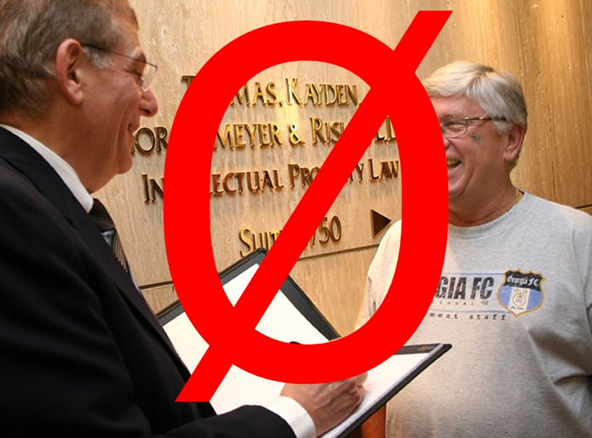

**Next, insert this new banner, picture, and link in its place above the South Hills Movers story on** [**www.officemoves.com**](http://www.officemoves.com)

**Every Branch/Every Employee—FIRST CLASS Moving Systems IOMI® Trained and Certified**

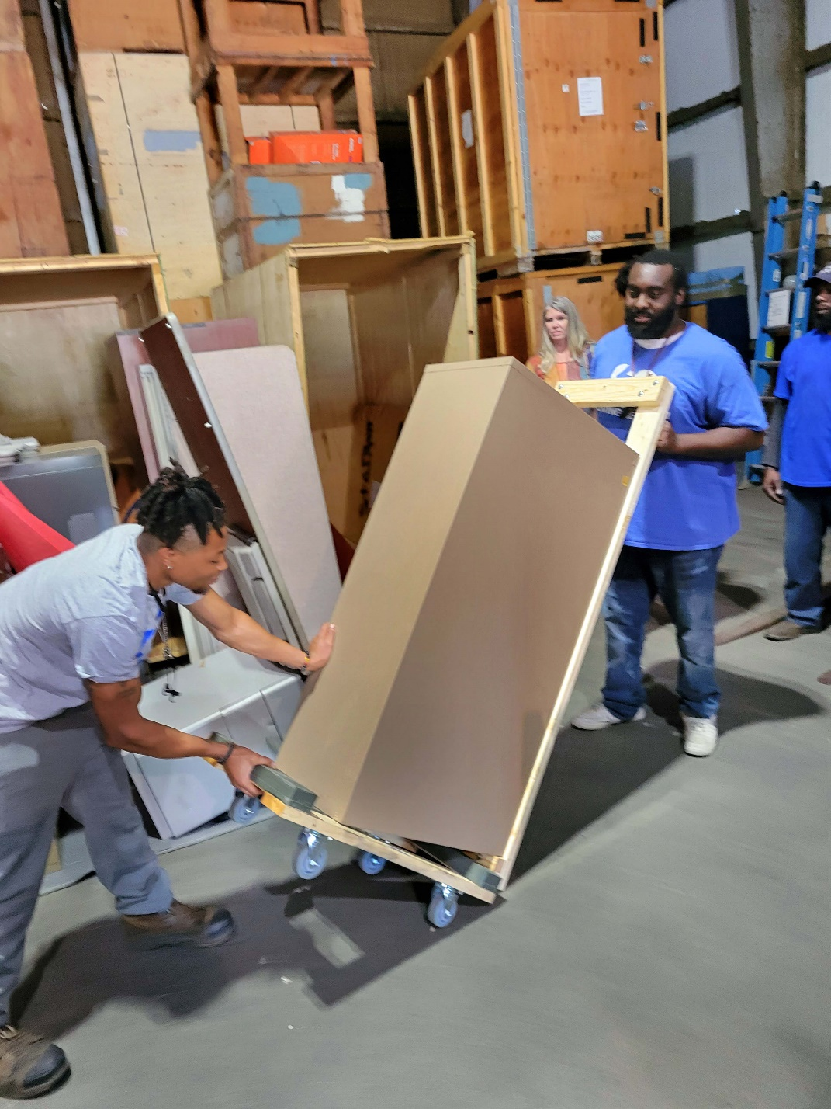

**First Class Moving Systems, Inc. invited Ed Katz, IOMI®, for office moving training to its newly acquired Gulfport, MS branch. See:** [**https://officemoves.com/2017/03/12/if-you-ever-sell-iomi-i-want-to-buy-it-im-that-much-of-a-believer/**](https://officemoves.com/2017/03/12/if-you-ever-sell-iomi-i-want-to-buy-it-im-that-much-of-a-believer/)

**Link the headline and picture above to First Class’ existing page on my website above their existing story of** [**https://officemoves.com/2017/03/12/if-you-ever-sell-iomi-i-want-to-buy-it-im-that-much-of-a-believer/**](https://officemoves.com/2017/03/12/if-you-ever-sell-iomi-i-want-to-buy-it-im-that-much-of-a-believer/)

**The story below and the pictures go above their existing story and pictures**

**Every Branch/Every Employee—FIRST CLASS Moving Systems IOMI® Trained and Certified**



**April 12th—14th, 2023, Gulfport, Mississippi** – First Class Moving Systems, Inc. has strengthened its commitment to safety and quality service by partnering with IOMI® for all its newly acquired branches in Mississippi, Florida, and New Jersey. **Since 2016, the company has required every employee, every year, who is involved in office moving, to complete IOMI’s online intensive training**.

This time, Chris Hunt, CEO hired the International Office Moving Institute (IOMI) https://officemoves.com/about/ to teach his Gulfport team **in person** the best practice methods to estimate accurately, and to ensure his moves finish on time for the price quoted with a minimum risk of damage to his clients’ furniture, computers, and the office space.

According to Ed Katz, IOMI instructor, the First-Class team is poised to make the most of Hunt’s investment. “First Class is one of the best groups of students I have ever trained. This team is sharp, conscientious, and passionate about rendering the best service possible,” said Katz.

(Steven and Lara, please arrange these pictures any way you like to make them look great.)

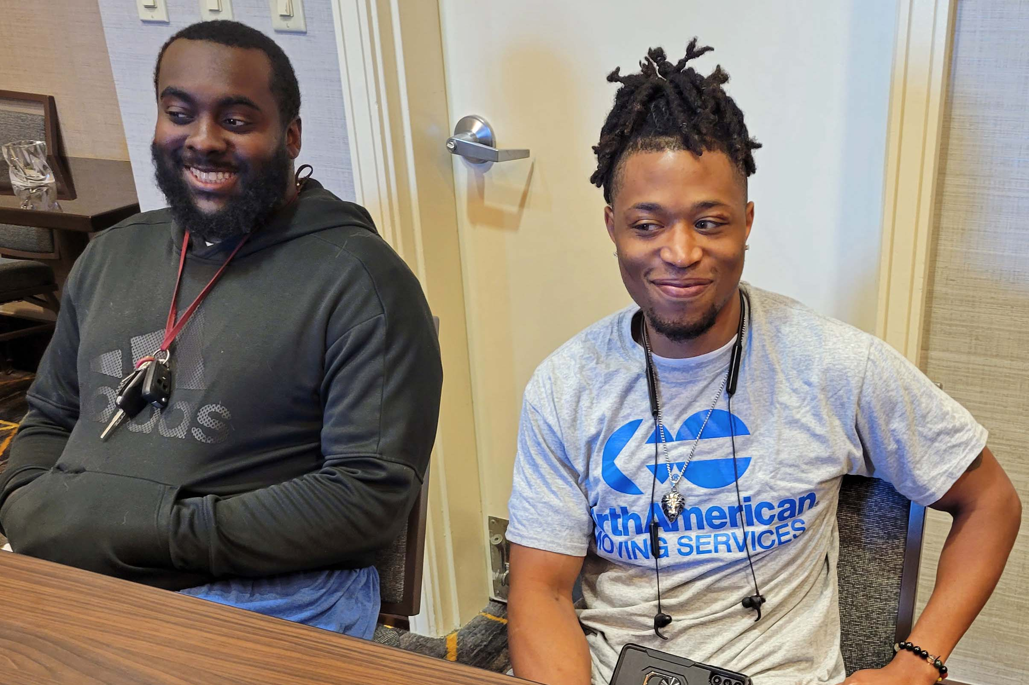

Left to Right: Devante Gill and D’Angelo Murphy

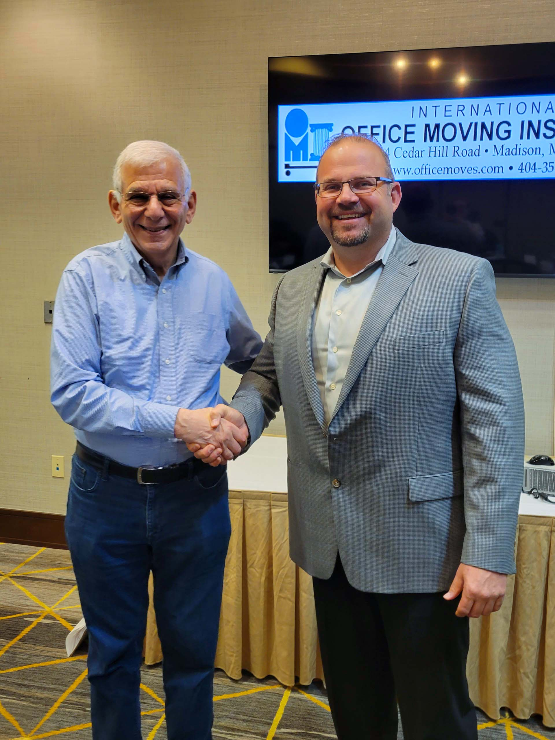

Left to Right: Ed Katz, IOMI® and Chris Hunt, CEO

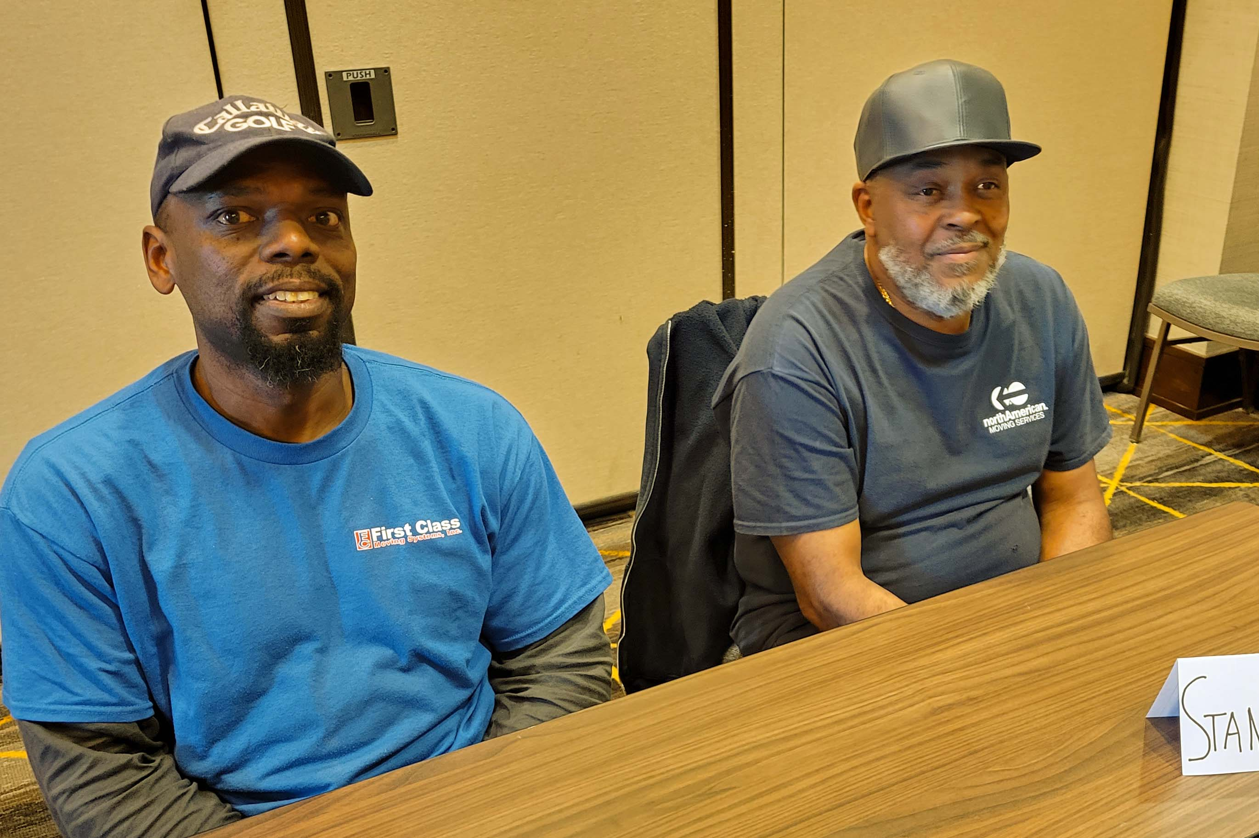

Left to Right: Willie Zanders and Stanley Smith

Left to Right: Eric Williams and Christopher Sonnier

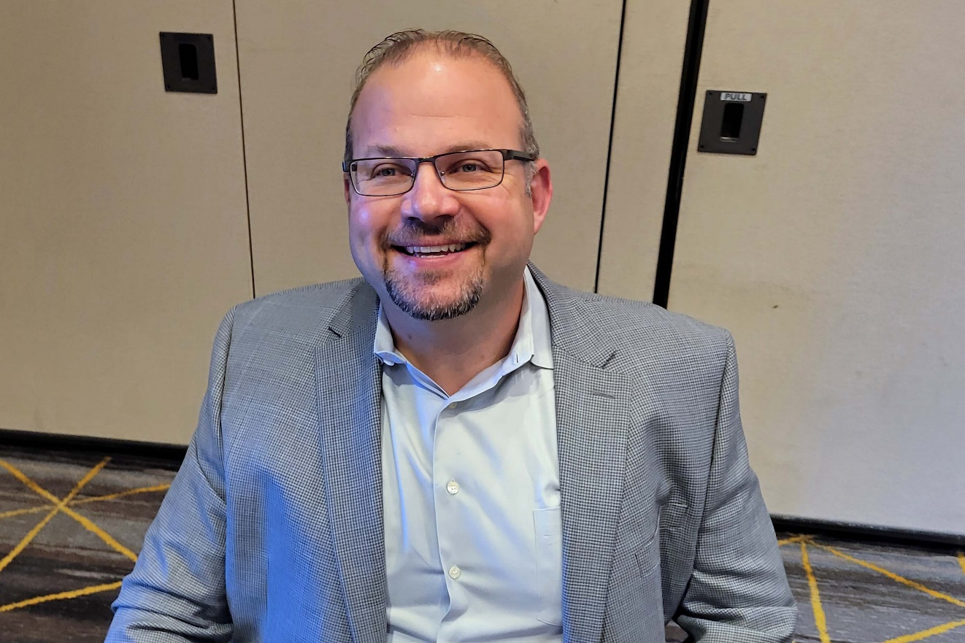

Chris Hunt, CEO, First Class Moving Systems, Inc.

Jennifer Stadler, Director of Commercial Client Services

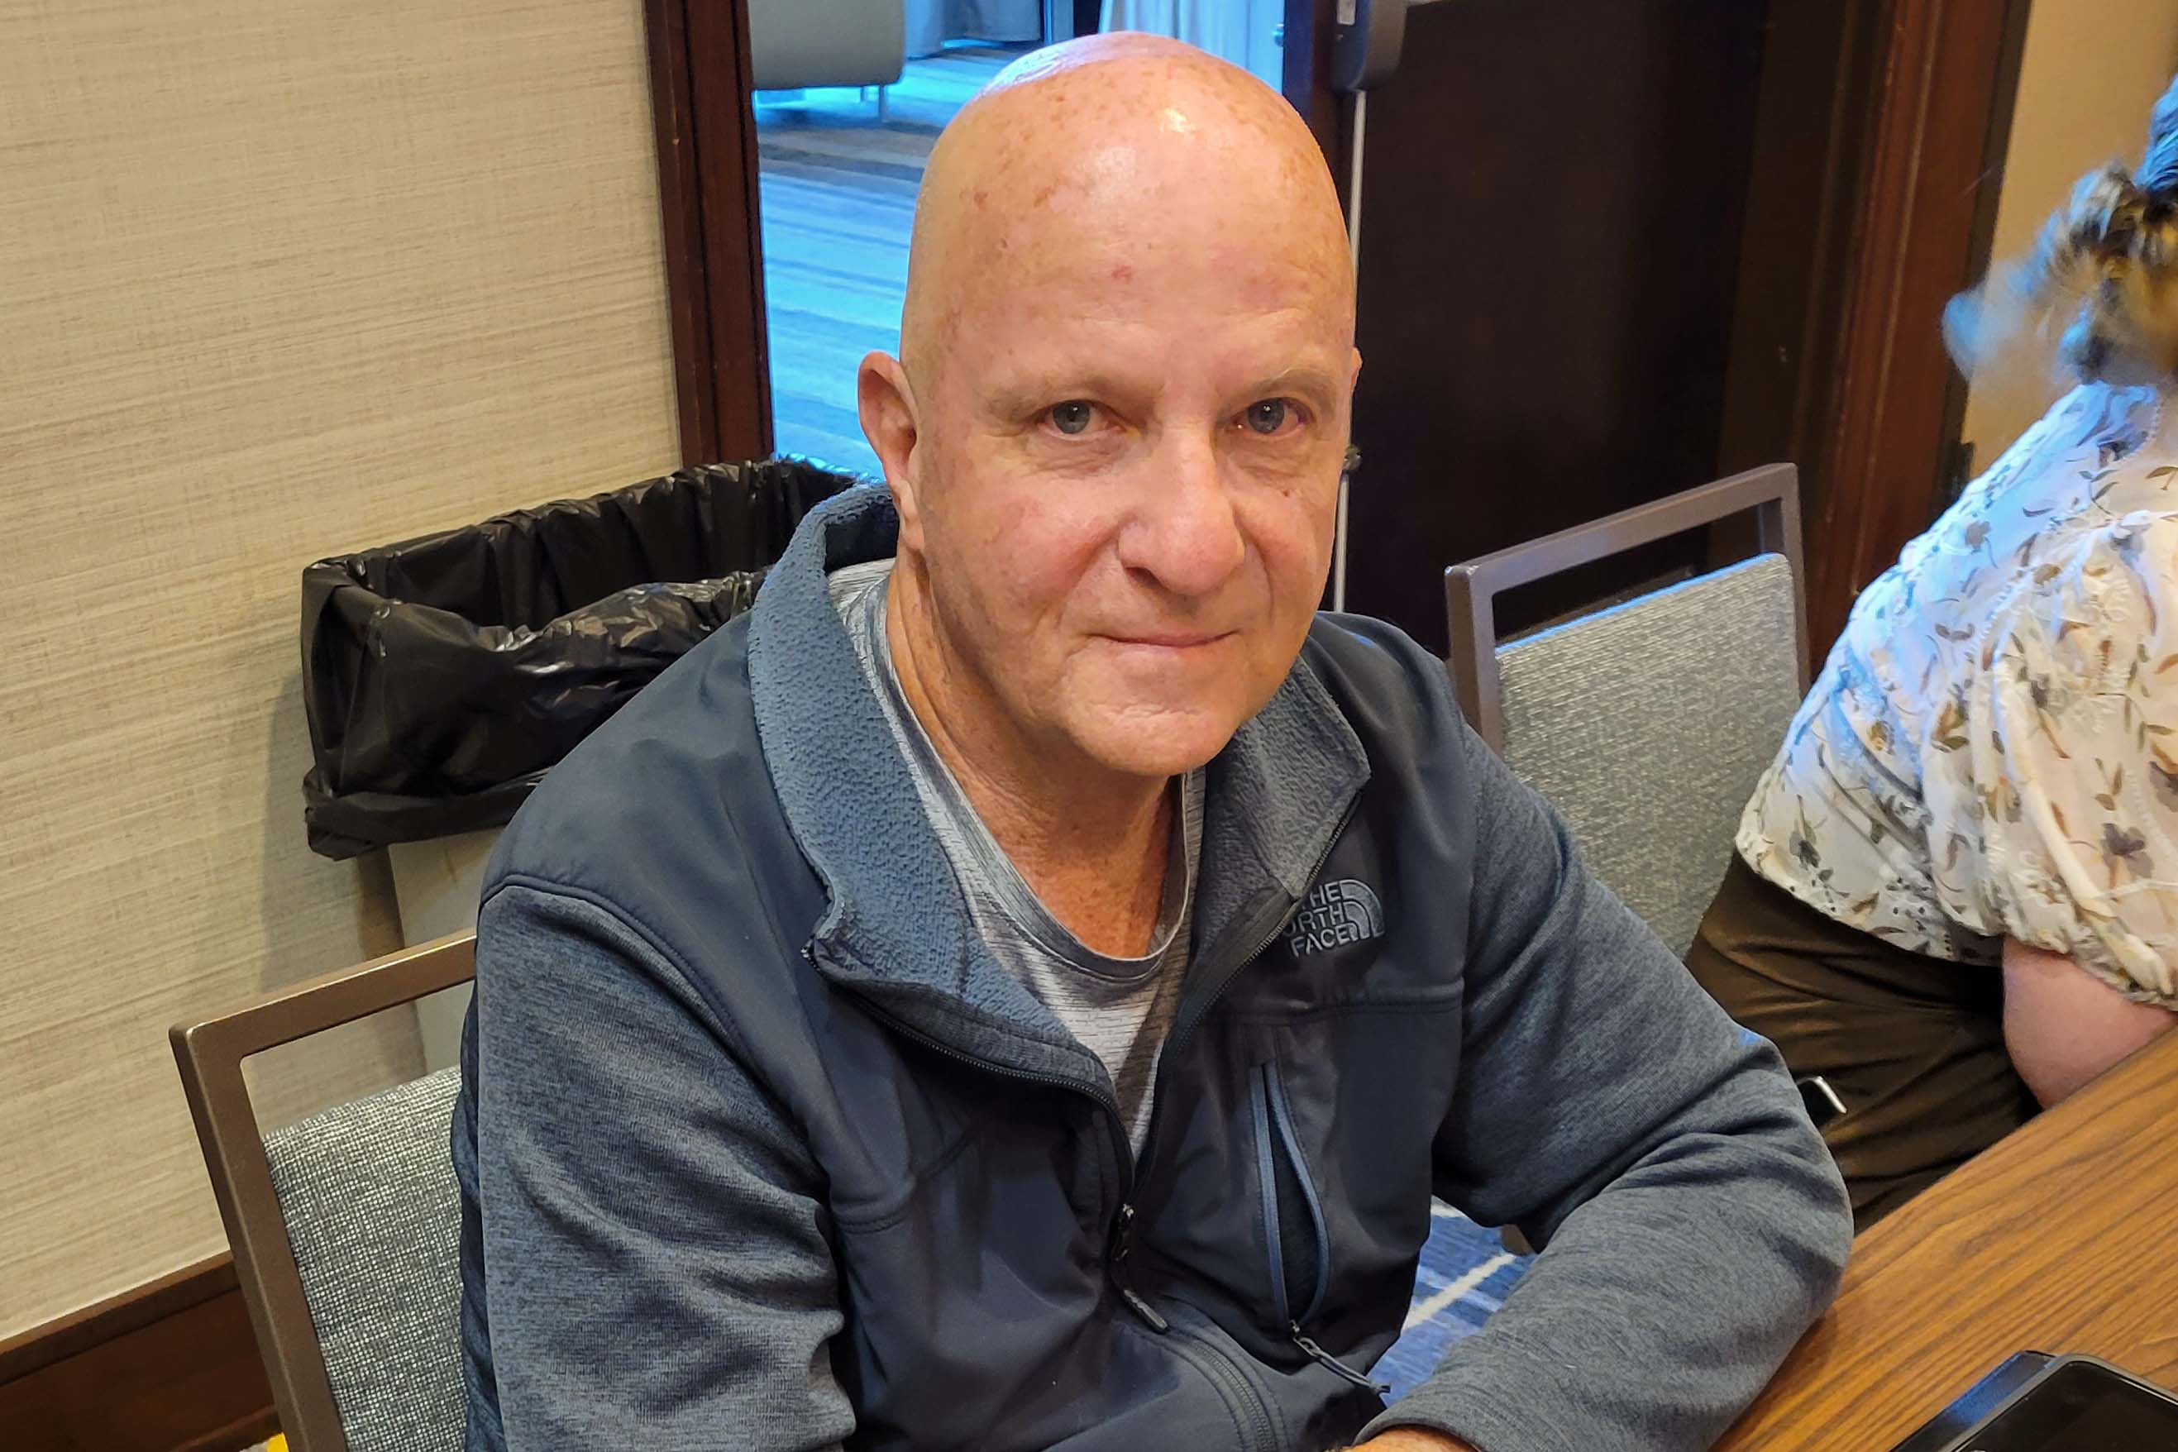

Peter Weil

Lisa Hedin, Branch Manager

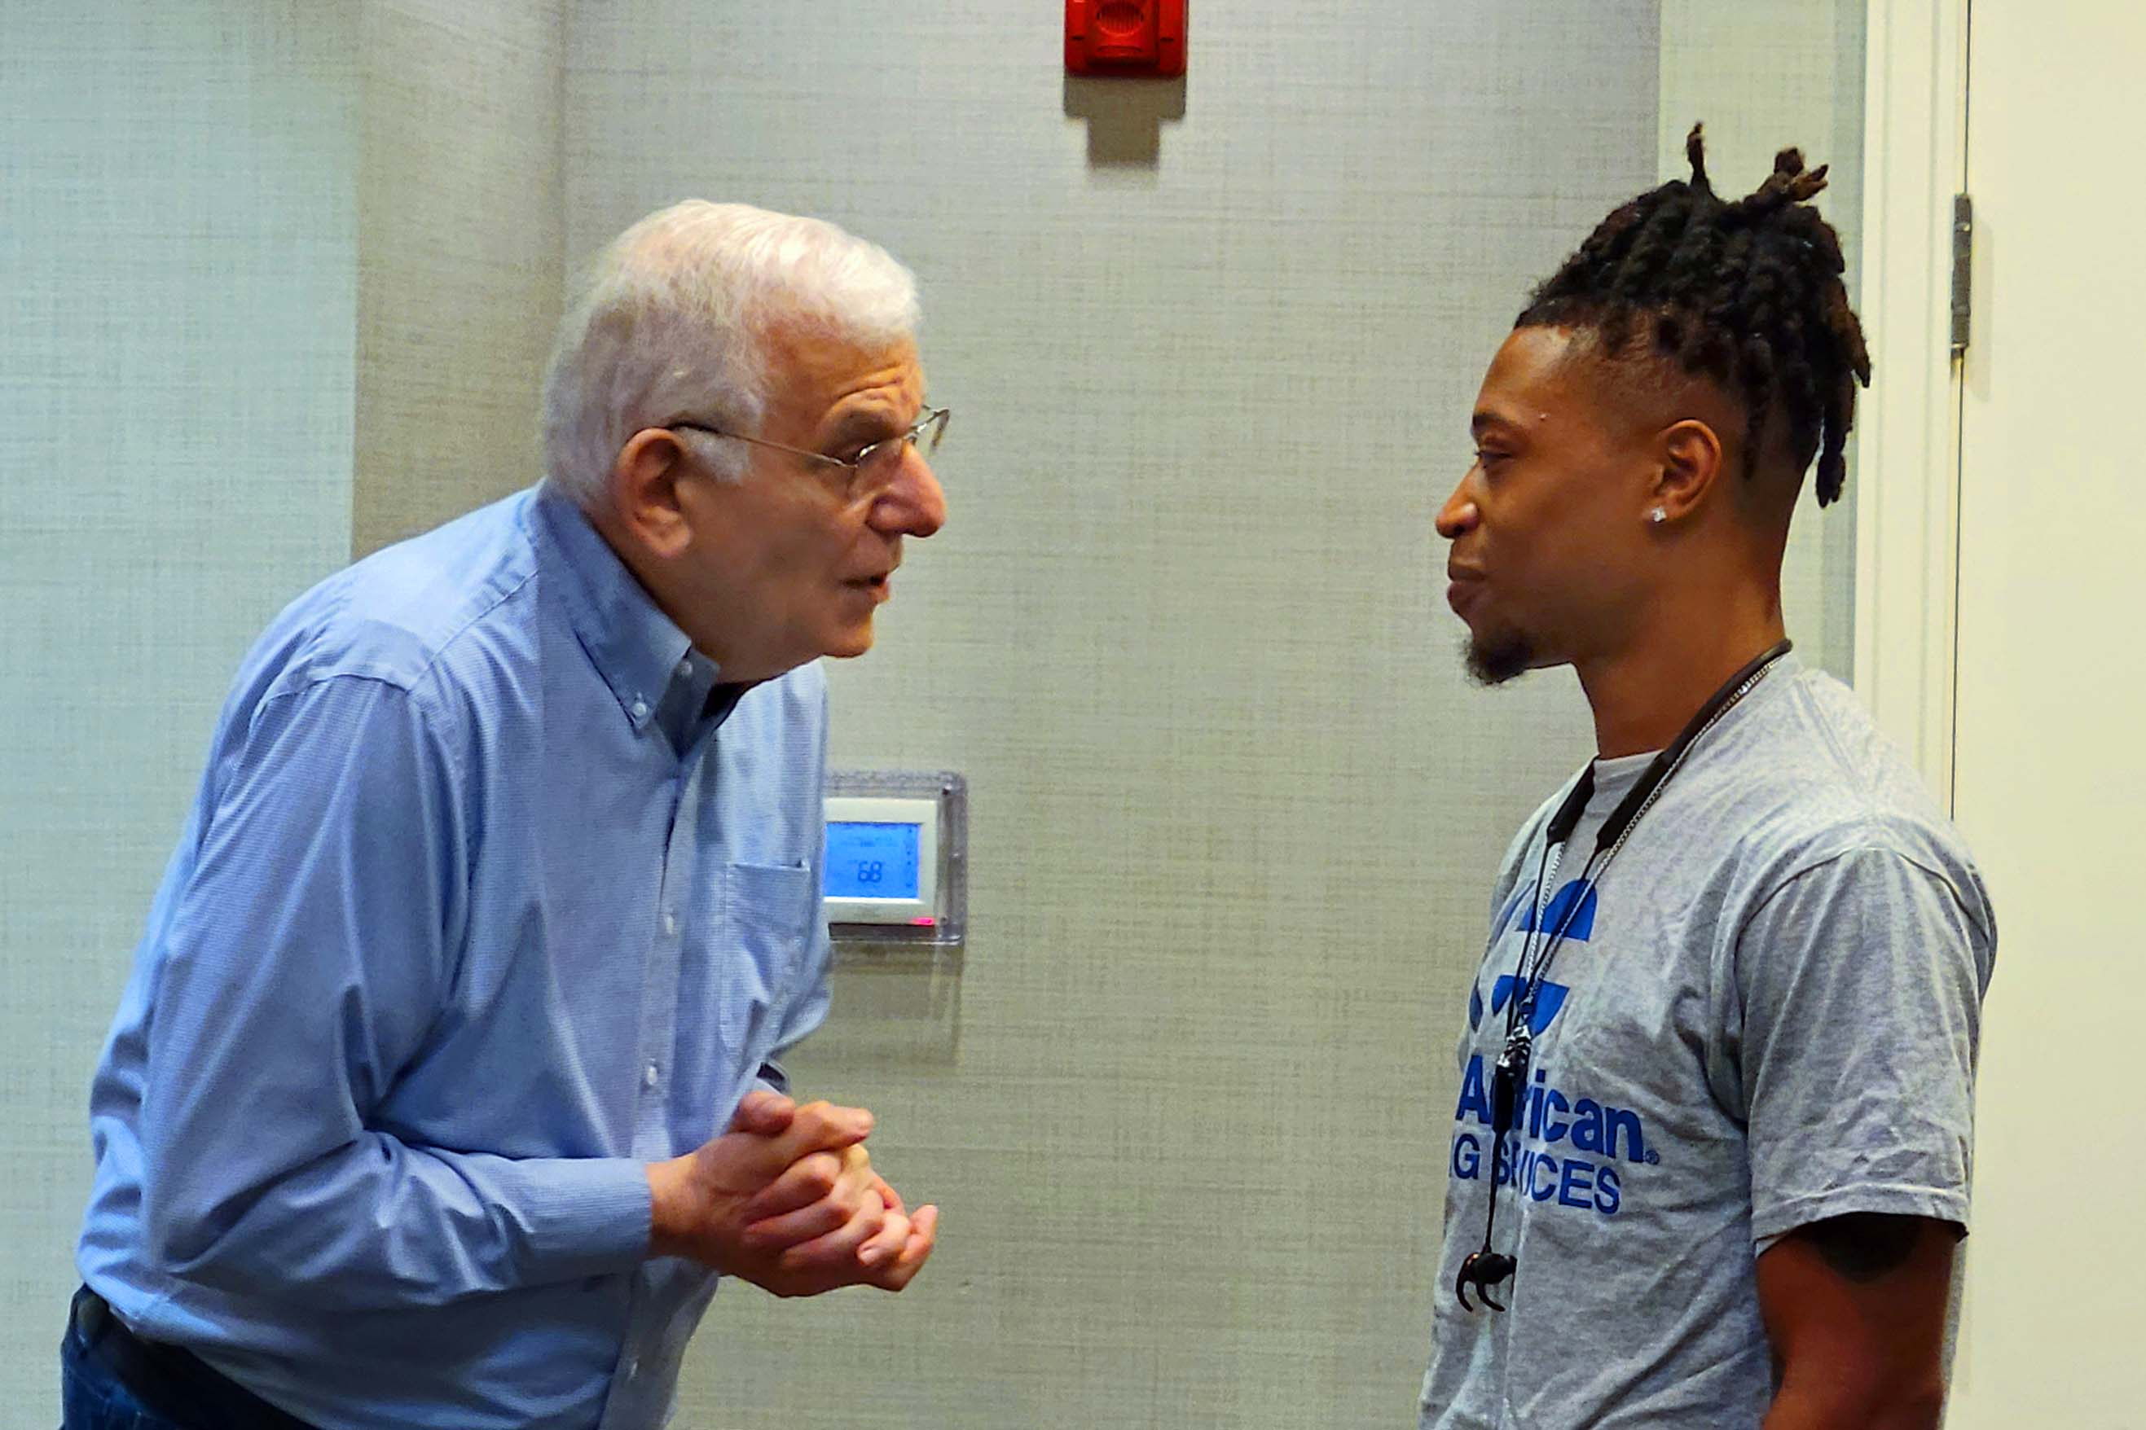

Role playing, supervisor training with Ed Katz and D’Angelo Murphy

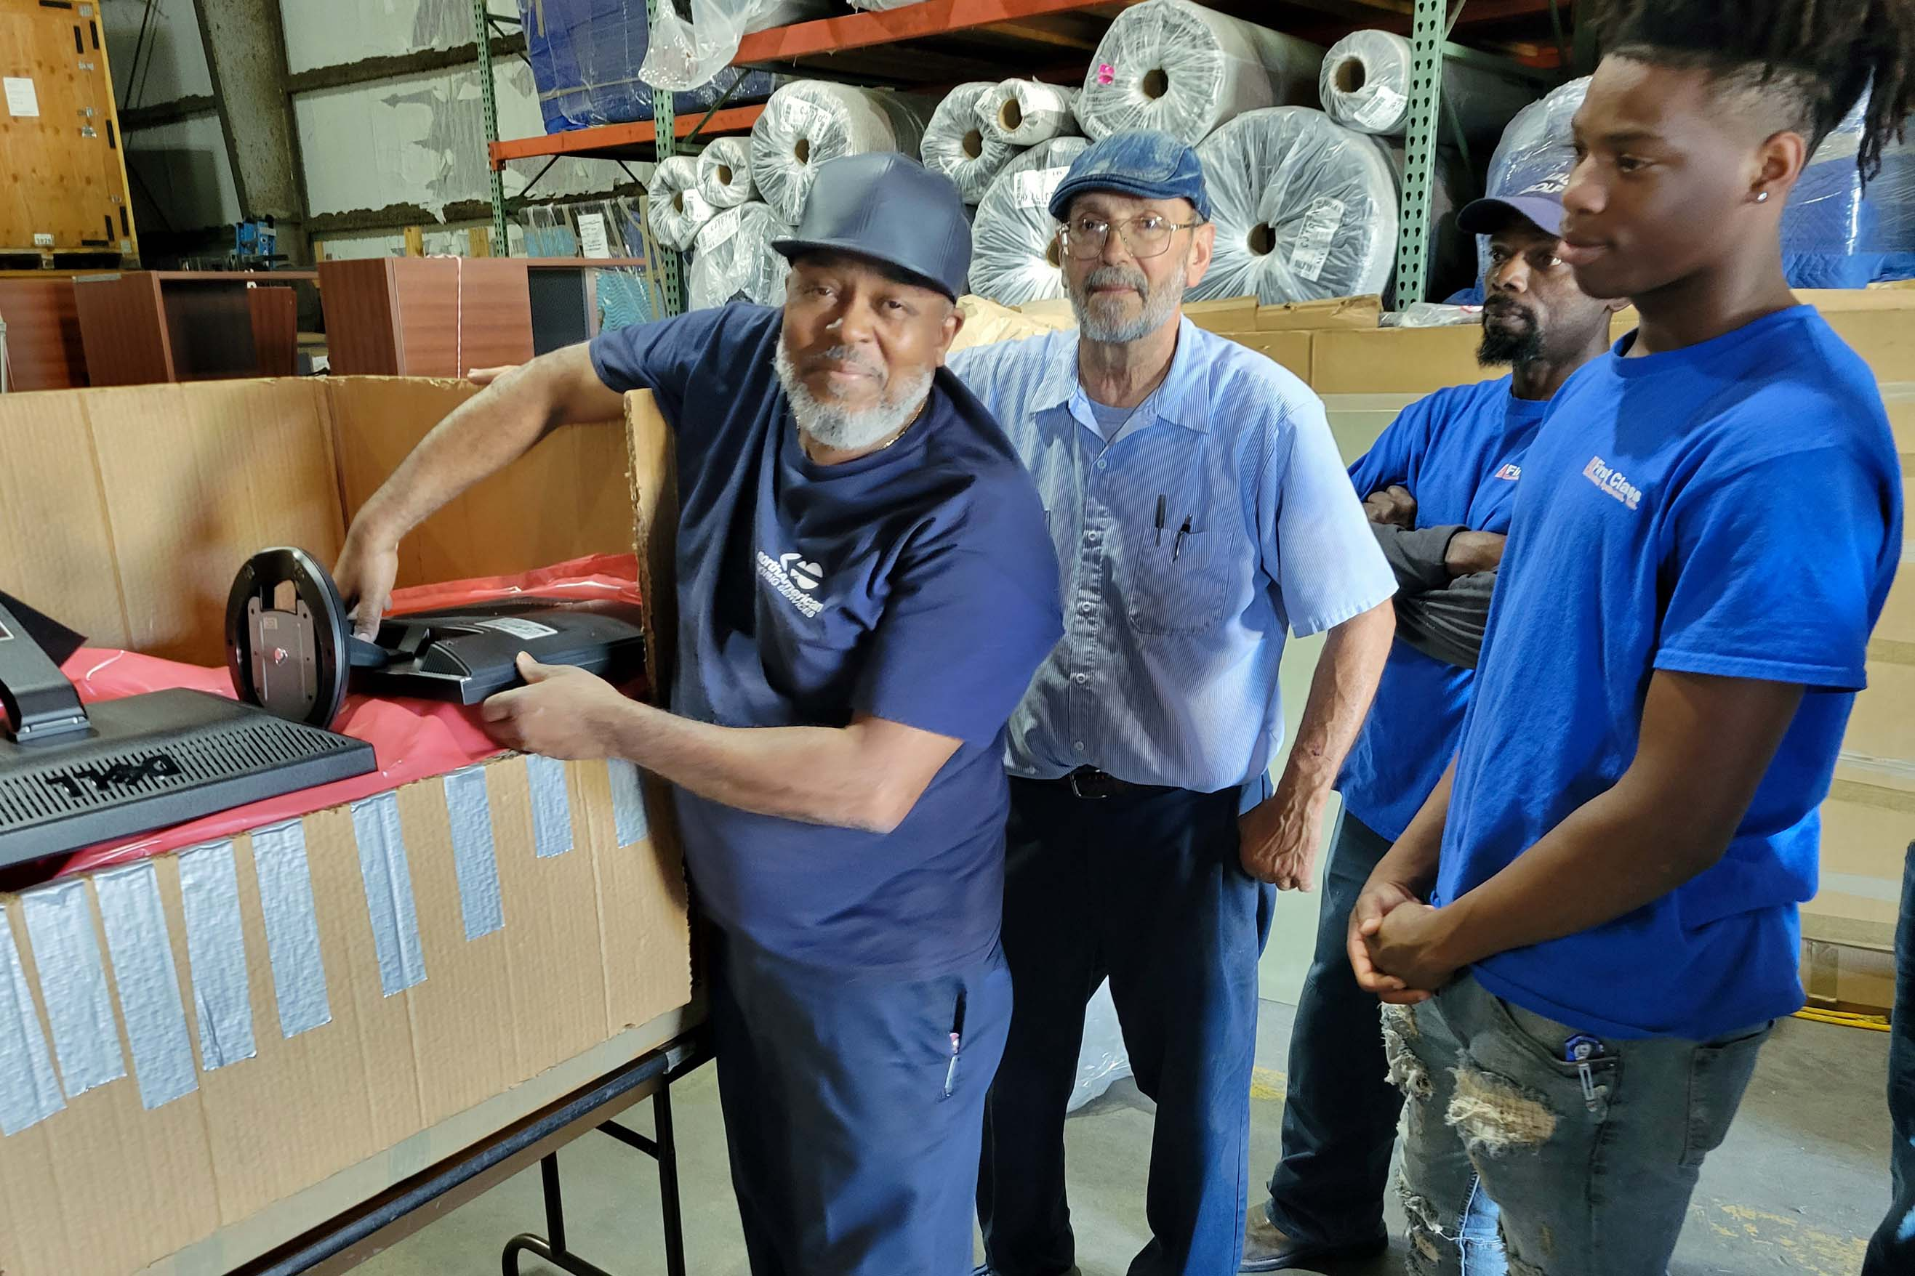

“Hands-on” training on the safest method for moving computers

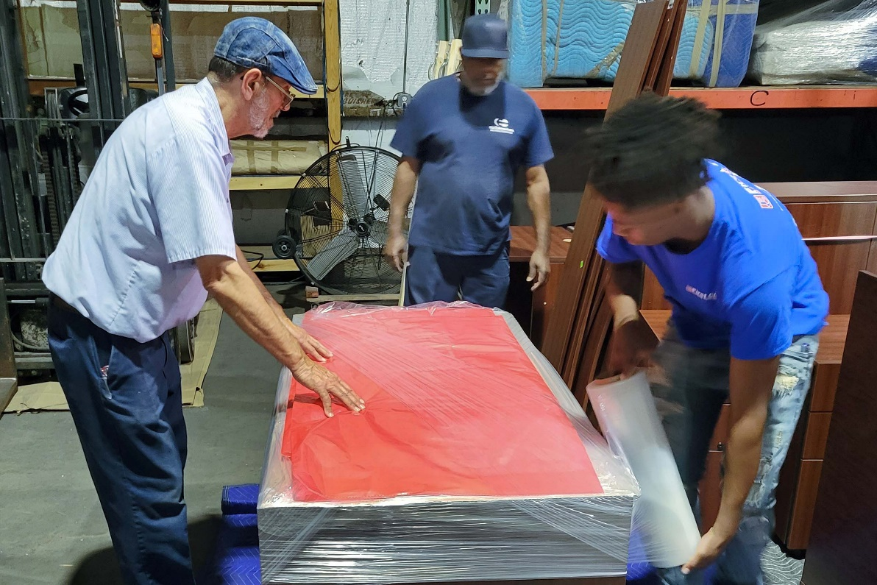

“Hands-on” training on how to move glass safely

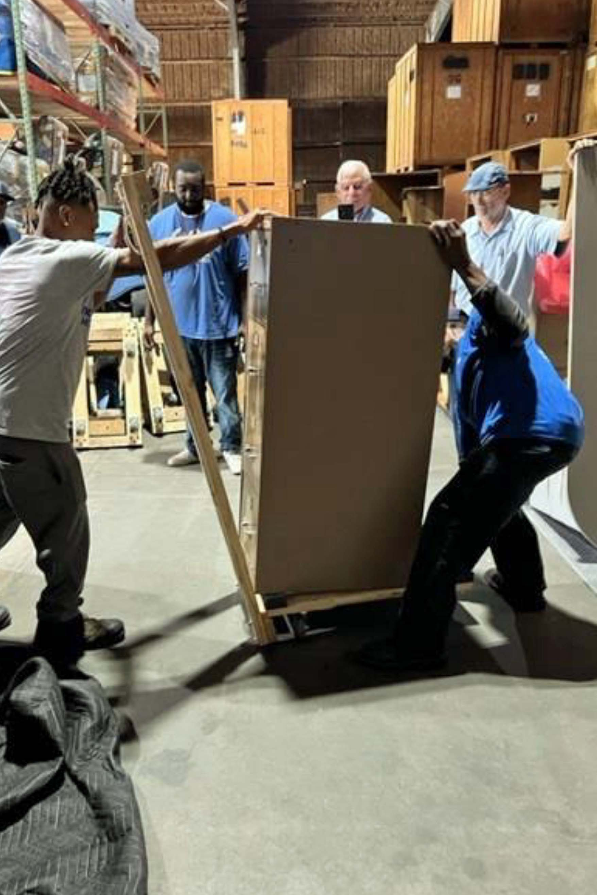

“Hands-on” training on how to move file cabinets

“Hands-on” training on how to install the very best floor protection—**Polynite®**

What happens if you make the mistake of sending Ed Katz, IOMI, on an office move.